Search Ads Rating Guidelines
April 2025

Contents 3
- Introduction 4
Ads for Apps and Games 4
Why Show Ads? 4
What Makes an Ad Relevant? 4
- Rating Interface 5
- Ad Relevance 7
  - Relevance Question 7
. 7
  - App Queries 8
When is an app ad relevant? 8
When is an app ad not relevant? 8
App Similarity 9
Local Knowledge 9
Rating Examples 10
Excellent App Examples 10
Direct Competitor 11
Same Developer 11
Good App Examples 12
Accessory Apps 13
. 14
Acceptable App Examples 14
. E rror! Bookmark not defined.
Bad App Examples 15
Offensive Results 17
  - Game Queries 18
Game Query Rating Examples 18
Excellent Game Examples 18
Good Game Examples 19
Contents
Acceptable Game Examples 20
Bad Game Examples 21

Introduction
These guidelines describe how to rate Search Ads shown in the iOS App Store. For this task, you will rate the relevance of these ads to user queries. The information produced will be used for evaluation purposes only.

Ads for Apps and Games
When a user searches for an app or game in the App Store, they’ll see a list of results. At the top of that list, there will often be an advertisement for a different app or game. These ads are highlighted in blue and have the word “ad” embedded in them. Under the ad will be a list of results for the search they did.

Why Show Ads?
Ads help users discover apps and games related to their interests that they might not have known about or searched for.

What Makes an Ad Relevant?
An ad’s relevance is based on its relationship to the user intent, based on their search query.


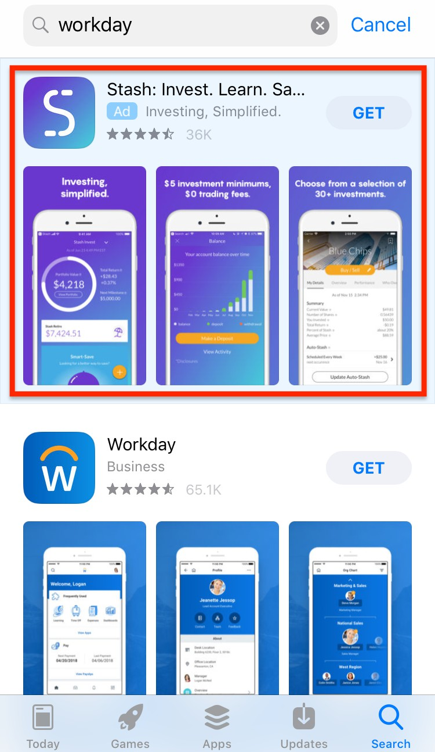
Ads can be relevant to user intent in several different ways. They can be exactly what the user was looking for, but they can also be something that the intent implied by the user’s query suggests they might be interested in.
Remember: An ad for an app or game does not have to be for, or be about, exactly what the user asked for to be relevant.

An ad for the query ‘workday’, with search results below.

Rating Interface
On the left-hand side of the rating tool interface, you will see the user search query. Under the query are links you can use to help begin your research on the query and what it means.
Under these links is another link to the App Store search results for the query. This will show you the results a search for the query at the App Store would give.
Remember to look at the search results only and not the ads (if any) that appear at the top of the result page.
In the center of the tool is the result ad to be rated. The ad shows you the name and icon of the advertised app, plus:
- Subtitle (a brief summary of what the app does)
- Review score and number of reviews
- Developer (the company or person that created the app)
For more information about the advertised app, including a detailed description and user reviews, click the icon or the name for a link to the App Store Preview page.
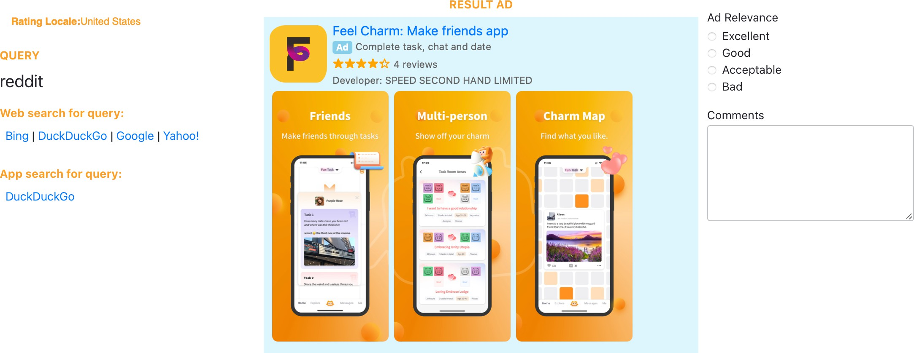

Based on this information, you will make a rating:
  - Ad Relevance
There is also a comment box where you can provide brief notes on how you chose your ratings. Comments should include:
  - The reasoning you chose your ratings
References or links to any research you did to understand the query or the result

Ad Relevance
This section will walk you through how to answer the relevance of the query to the app question, focusing first on queries for apps and then on ones for games.

Relevance Question
The Relevance question has four available rating options:
- Excellent - the app has a strong relationship to the user query and is among the most likely to be of interest to the user.
- Good - the app has some relation to the user query and is quite likely to be of interest to the user, but other apps might be more compelling.
- Acceptable - the app has a slight relation to the user query and the user would not be surprised to see it as an ad, but they aren’t that likely to be interested.
- Bad - the app doesn’t have any relation to the user intent, and/or seems likely to surprise the user and make their experience worse. Note: If you choose this rating, you must leave a comment explaining why.
Note: Don’t demote apps for few or low review scores, high prices, or poorly written descriptions.
Apps or games should also not be demoted because they that cost money, even if the query is for a free app or includes the word “free.”
Note: If an ad is for an app or game that’s relevant to the query but not available in the test locale, rate it Acceptable.

If you are using a Mac, you might get the following pop-up window when the app or game is not available in the test locale. For example: https://apps.apple.com/us/app/id1438382098 app is not available in the United States locale, so if you open this link, you will get a pop-up shown in the below screenshot.
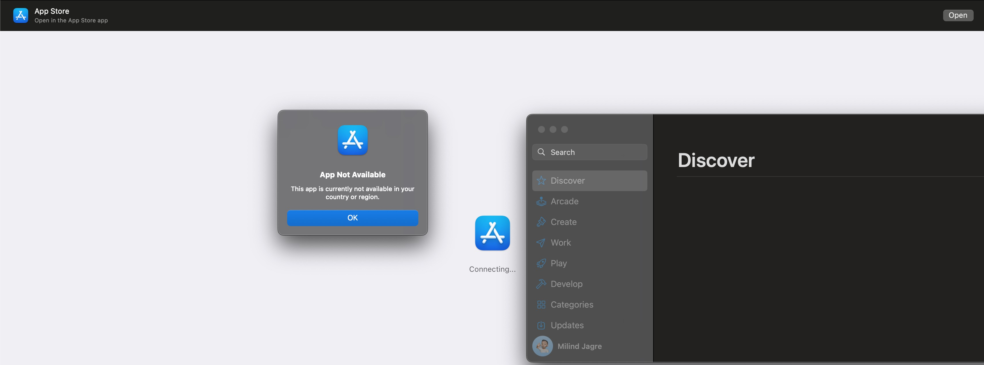

App Queries
When the user query is for an app, the relevance of an ad should be rated based on how it relates to the user intent conveyed in the query, based on the functionality of the app and the audience it seems to target.

When is an app ad relevant?
A query often suggests a range of multiple possible interests or needs that could be satisfied by an app. For every query, think about where the result ad falls in this range.
For example:
    - A query for a gym app shows the user has a definite interest in apps for working out in a gym, and less strongly implies a broader interest in apps for other fitness activities, such as running
    - A query for a dog training app shows the user has a clear interest in apps for dog obedience, a strongly implied potential interest in dog-related apps overall, and a weaker potential interest in pet-related apps that have some functionality of use to dog owners
    - A query for a calculator app shows a strong interest in or need to do math, which could be for professional activities, school homework, or something else. In this case, it’s not possible to infer very much else about this user beyond that interest in calculating something.

App ads that should be rated Excellent have functionality matching the most obvious interests or needs, as those are ads the user is highly likely to interact with. Those relating to less strongly implied intents should be Good, as they are still useful as recommendations, helping to expose the user to new apps that they might be interested in.

When is an app ad not relevant?
If an app ad is on the relevance borderline, where a user is likely to recognize that the functionality it provides could be relevant to their interests or needs, but the link is weak, choose Acceptable.
Reserve the Bad rating option for apps that seem like they would negatively catch the attention of a user expecting the ad to be relevant. This can include the following scenarios:

Issue | Example | Notes
Ad app has no perceivable link to the user’s interests or needs | Query: a banking app  Ad: a birdwatching app | Banking and birdwatching have nothing to do with one another. Rate Bad.
Ad app is technically linked to user intent, but it seems illogical to advertise based on that link | Query: a grocery shopping app  Ad: a clothes shopping app | Both involve shopping, but for completely different things and with very different audiences. Rate Bad.
 | Query: a document to PDF scanner  Ad: a virus scanner app | Both involve some kind of scanning, but not in a way that makes one of interest to users of the other. Rate Bad.

Issue | Example | Notes
Intent is in the same broad category as advertised app, but they fit into distinctly different niches that don’t relate to each other | Query: a dog training app  Ad: a cat training app | Both are related to pets, but there’s no evidence to assume this user has cats as well as dogs. Rate Bad.
 | Query: a dictionary app  Ad: an app designed to teach young children words | Though the user shows a need to look up words, there is no basis to assume they want to do so for a child’s education. Rate Bad.

App Similarity
When the user query and the result ad seems to serve the same purpose, consider the similarity of the queried app and the result app when deciding how likely the app is to be of interest to the user.
Ads for apps that seem to be competing for the same users by offering a similar feature set should be considered highly likely to interest the user, and be rated Excellent.
Examples of pairs of competing apps include:
- Uber vs Lyft - ride-sharing apps
- PowerPoint vs Google Slides - presentation software with similar features
- WhatsApp vs Facebook Messenger - one-to-one and group messaging
- Twitterific vs Tweetbot - apps for using Twitter, with similar features
(Users may use both Uber and Lyft in order to catch the nearest car, or both WhatsApp and Facebook Messenger to talk to different friends, but not because the apps do anything fundamentally different).
Apps that have functional overlap but some considerable difference between them are potentially less likely to interest the user, for example:
- Facebook vs. Twitter - sharing status reports with people you know vs broadcasting your thoughts to a public audience
- Instagram vs. Snapchat - sharing photos via a newsfeed vs sharing photos via messages
- Microsoft Word vs. Byword - heavyweight, all-purpose writing app vs light minimalist tool
Depending on how similar you find those feature sets, you might rate pairs of apps such as these either Good or Acceptable.

Local Knowledge
Always consider a query’s meaning in the context of the locale where it is being rated.
For instance, in most English-speaking countries, the user intent for the query “bbc" is most likely apps from the British Broadcasting Company, implying an interest in news, entertainment

etc. For those markets, apps for learning a language would not be relevant. But in some Chinese-speaking markets, watching and listening to the BBC is a popular way to learn English. Many users in these markets would see a clear relationship between a query for the BBC and an ad for a language learning app.

Rating Examples
The following sections will take you through examples of how to apply these concepts.

Excellent App Examples
These ads are for apps that seem to directly match the user intent, and are rated Excellent:

Query | Ad
uber eats |   Uber Eats: Food Delivery  Local Food Delivery  Developer: Uber Technologies, Inc.  ★★★★★ 295.8K reviews
Relevance | Excellent
As an exact name match that research confirms is highly prominent, this app is the most likely user intent.
fitness |   Fitbod Workout & Fitness Plans Home & Gym Personal Trainer Developer: Fitbod Inc.  ★★★★★ 176 Ratings
Relevance | Excellent
Satisfies user intent for apps that support fitness. The small number of reviews should not be considered, as it doesn’t make the app any less relevant.
math | 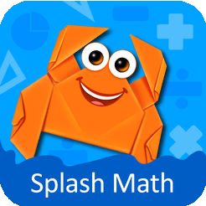  3rd Grade Math Games for Kids Multiplication Facts & Tables Developer: StudyPad, Inc.  ★★★★☆ 1.6K reviews
Relevance | Excellent
This is an extremely broad query that could encompass many different kinds of apps including calculation and problem solving apps, and also math games for any level and other educational aids, such as this one.
indeed |   LinkedIn  Connect, Apply & Get Hired Developer: LinkedIn Corporation  ★★★★★ 12.8K reviews

Query | Ad
Relevance | Excellent
Intent is for a job postings service, and LinkedIn provides this functionality along with other services of interest to a user seeking a job.

Direct Competitor
When the user query and the result is a direct competitor of the app the user wanted to find, rate Excellent:
Query | Ad
netflix |   Hulu: Stream movies & TV shows Browse films & watch series Developer: Hulu, LLC  ★★★★☆ 1.2M reviews
Relevance | Excellent
Netflix is a streaming service for watching movies and TV shows, Hulu provides the same functionality.
camera + |   ProCamera.  For Pro-Level Photos & Videos Developer: Cocologics  ★★★★☆ 287 reviews
Relevance | Excellent
User is looking for the app Camera+ which provides advanced “professional” level camera controls and options. This app does the same thing. The app costs money, but this should not
be considered in your relevance rating.
tubemusic | 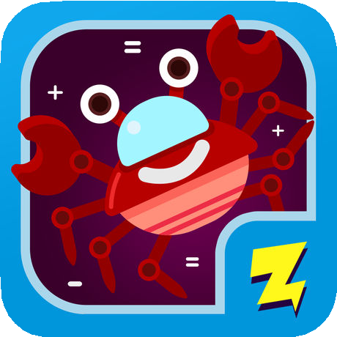  Trending Music Streaming Music tube player Developer: trending.fm Inc.  ★★★★☆ 42.2K reviews
Relevance | Excellent
Intent is for a music player that streams from YouTube and this does the same.

Same Developer
Note that If the query is the name of a developer and the ad returned is from that developer, the rating should be Excellent.

Query | Ad
adobe |   Adobe Lightroom CC  Powered by Adobe Photoshop Developer: Adobe  ★★★★☆ 1.6K reviews
Relevance | Excellent
Query for the name of a developer, this app is made by that developer.
uber |   Uber Eats: Food Delivery  Local Food Delivery  Developer: Uber Technologies, Inc.  ★★★★★ 295.8K reviews
Relevance | Excellent
The user is probably looking for the main Uber app, but this is another app from the same company and seems like a great ad to show.
The developer’s name can be found in the ad or on the App Store page.
Apps from the same developer as the queried app that don’t otherwise match the themes or functionality of that app should be rated no lower than Acceptable, as they can be automatically considered to be at least slightly relevant to that query:

Query | Ad
disney emoji blitz | 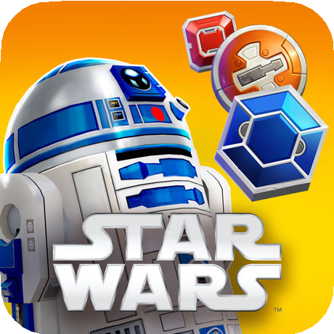  Star Wars: Puzzle Droids™ Match-3 Puzzle Adventure Developer: Disney  ★★★★☆ 960 reviews
Relevance | Good
Both apps developed by Disney for Disney properties, and are a functionally similar match-3 type of game. However, the queried app is mainly themed around classic Disney and Pixar characters, versus the sci-fi theme of the advertised app, so it doesn't seem like a perfect match to user interests.

Good App Examples
Downgrade to Good for results that are still close enough to the user query to be logical and potentially of interest to the user, but that seem less strongly linked to the query.
The weakness might be in the app's function, themes, and/or perceived target audience.

Query | Ad
daily planner | 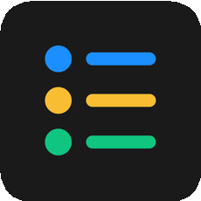  Productive - Habit Tracker 4+ To Do List & Goals Planner Apalon Apps  ★★★★★ 61.7K Ratings
Relevance | Good
The user is seeking a daily planner and this app offers a way to plan and track healthy habits and goals for each day. It does not deliver the exact functionality requested in the query, but is could easily be of interest to a user who is seeking a way to organize their day.
english spanish dictionary |   Camera Translator: Translate+ Lens to scan & translate photo Developer: Vulcan Labs Company  ★★★★★ 16.8K reviews
Relevance | Good
This user is looking for a dictionary featuring two specific languages. Their intent is clearly related to translation from one language to another. The Camera Translator app is not a dictionary and can translate more than two languages, but it’s linked closely enough to the user’s intent that it’s quite likely to be of interest to them.
doordash | 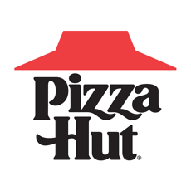  Pizza Hut - Delivery & Takeout Order Food, Track, and Rewards Developer: Pizza Hut, Inc.  ★★★★☆ 1.9M Ratings
Relevance | Good
The Doordash app lets users order almost any kind of food from almost any restaurant for delivery. The Pizza Hut app is also for food delivery, but is limited to one well-known restaurant chain. As pizza is a very commonly ordered food item, this app will still appeal to many users.
espn 3 |   SofaScore Live Sports Results 20 Sports - Premium coverage! Developer: SofaScore  ★★★★★ 212 reviews
Relevance | Good
Query is for the name of a TV channel. This app doesn’t directly address the user’s desire to watch sports, but providing live scores-and-chat is also very likely to be of interest to this user.

Accessory Apps
Ads for accessory apps, which provide some kind of add-on or extra functionality to the app the user was searching for, should also be rated Good:

Query | Ad
youtube |   Video Tube™ - Stream and Play  The most used video player! Developer: Tube Studio  ★★★★☆ 1.1K reviews
Relevance | Good
User is reasonably likely to be interested in this app as it complements YouTube, but a
YouTube competitor would be preferred.
instagram |   VFollowers Track for Instagram! Unfollow and Follow Tracker Pro Developer: Component Studios  ★★★★☆ 2.6K reviews
Relevance | Good
User is reasonably likely to be interested in this app as it complements Instagram.
whatsapp | 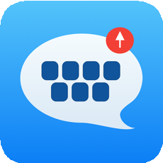  Textify - Watch Keyboard Type/Send messages on Watch Developer: Mehdi Amiri  ★★★★☆ 3 reviews
Relevance | Good
This app allows sending text messages from an Apple Watch, which supports the user’s implied intent to send messages using WhatsApp.
Note: When rating app ads that require a particular device, assume that the user does own one of these devices.

Acceptable App Examples
Rate Acceptable for apps that have a slight relation to the user query, and that users would not be surprised or offended to see as ads, but that they aren’t that likely to be interested in.

Query | Ad
photo collage |   Flyer Maker - Poster Templates Graphic Design, Banner Maker Developer: Bhavesh Gabani  ★★★★★ 6.6K Ratings
Relevance | Acceptable

Query | Ad
Intent is for an app to make photo collages, result is intended for making posters. Both relate to graphic design, but it's not particularly likely that the user would be interested, but they
would not be surprised or offended to see this.
khan academy |   Elevate - Brain Training Award-winning brain games Developer: Elevate, Inc.  ★★★★☆ 42.6K reviews
Relevance | Acceptable
User is interested in doing online courses through Khan Academy, so it's not too likely they’re also going to tap on game ads, but this one is at least vaguely related to learning.
texas lott |   Slots Casino HD Slotomania Vegas Slot Machine Games Developer: Playtika LTD  ★★★★★ 3.5K reviews
Relevance | Acceptable
Intent is for Texas Lottery app. Though this is technically a form of gambling and therefore the ad is not jarringly irrelevant, checking your lottery numbers is not that likely to correspond to
an interest in virtual slot machines.
keyboard symbols |   Emoji Me Keyboard | Zmoji Avatar Emojis & GIF Maker Developer: MobileTrends Inc.  ★★★★☆ 2.2K reviews
Relevance | Acceptable
The user seems to be looking for apps like Symbol Keyboard, which allow you to send various symbols in a text message. Though the advertised app does also provide keyboard functionality, there's not a big overlap between symbols and personalized emoji.
american express |   Coinbase — Buy & sell Bitcoin Secure Cryptocurrency wallet. Developer: Coinbase Inc.  ★★★★★ 840.4K reviews
Relevance | Acceptable
This query is for a specific financial services institution. Since financial queries in particular can indicate a very broad range of interests and intents, this ad for a particular kind of financial service, Bitcoin, could have some appeal to the user.

Bad App Examples
Rate Bad when you can’t see any relationship between the query and the ad, or when the functionality of the intent and ad are so mismatched as to be potentially embarrassing.

Query | Ad
google docs |   Duet Display  Be Twice as Productive Developer: Duet, Inc  ★★★★☆ 17.9k reviews
Relevance | Bad
Query is for a document creation and collaboration app, ad is for an app that turns a phone or tablet into a display. A user looking for a way to create docs would have no interest in this app.
noaa hurricane |   Aerovie, electronic flight bag (EFB)  Weather  Developer: Aerovie, LLC  ★★★☆☆ 20 reviews
Relevance | Bad
User intent is for hurricane trackers using National Oceanic and Atmospheric Administration data, such as NOAA Now. Result app also uses weather data, but for pilots to monitor their flights, so there's no reason to think this user would be interested.
netflix | 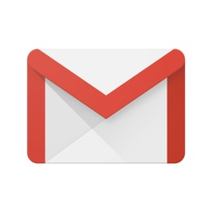  Gmail  Secure,fast & organized mail Developer: Google LLC  ★★★★☆ 114k reviews
Relevance | Bad
Query is for an entertainment app and the ad is for an email app. These two have nothing in common, and a user looking to watch TV or movies would not be interested in email.
multiplication for kids 2nd grade | 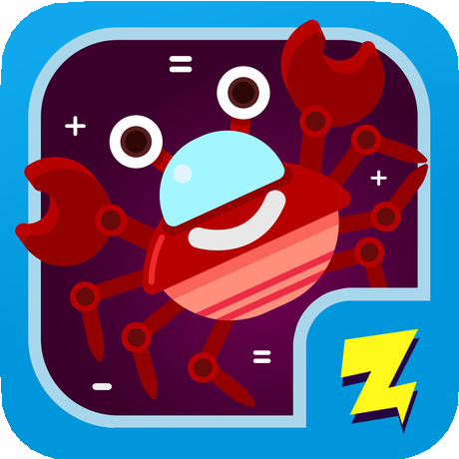  Zap Zap Kindergarten Math  Fun elementary math games Developer: Visual Math Interactive  ★★★★☆ 11.2K reviews
Relevance | Bad
This query is highly specific, looking for apps to teach multiplication to 2nd grade (7-8 year old) children. Though the ad fits under the broad umbrella of “educational apps”, it’s only suitable for teaching addition, subtraction etc. to kindergarten (5-6yo) children, and there is nothing in the query to suggest that the user also has a child in that age group.
mobile passport |   Mobile Legends: Bang Bang Play with the world Developer: montoon  ★★★★☆ 228.4 reviews
Relevance | Bad
Query is for a passport app that helps save time when entering American airports, result is a strategy game. Even though they both have “mobile” in their names, they have nothing in common.

Query | Ad
lego |   letgo: Buy & Sell Secondhand Quickly Sell Things Locally Developer: Ambatana Holdings B.V  ★★★★☆ 125.1K reviews
Relevance | Bad
The algorithm appears to have corrected “lego” to “letgo”, which is clearly not a match.
color snap |   Recolor - Coloring Book  3D coloring  Developer: Sumoing Ltd  ★★★★☆ 8.8K reviews
Relevance | Bad
The intent is for a photo color management app, and the result is a coloring book. The word “color” is being used in two completely different contexts, and there's no reason to think the user would be interested in the ad.

Offensive Results

Query | Ad
serene noises |   Gun Firearm Ammo Database  Inventory for guns collectors. Developer: iCollect  ★★★★☆ 41 reviews
Relevance | Bad
This is not relevant to the query, and the reference to guns has potential to upset readers looking for calming noises.
fb messenger |   Grokio Communities  Communities for every interest. Developer: Grokio Communities LLC
Relevance | Bad
Grokio Communities is an app that connects users with interests in specific adult activities. The query does not indicate that the user has any interest in adult content, so it should be rated Bad.
Rate Bad for any cases where the ad returned is for something that doesn’t match the query and could be offensive to the user, given that they didn’t ask to see it:

Game Queries
When the user intent is for games, rather than apps, your considerations should be somewhat different. A user looking for games is not looking for something to serve a particular purpose, but for something to entertain them.
The relevance of a game ad should be based on factors like:
    - Play style - what sort of experience does this game provide? What are the skills it requires, or activities it requires the player to do? For example, a game might test a player’s reflexes, or their problem-solving capabilities, or their ability to plan and act strategically
    - Presentation - what does the game look like? What sort of themes does it center around? For example, a game might be colorful and cartoony, or dark and horror-themed, or gritty and realistic
    - Audience - who is this game for? Does it seem to target particular users? For example, a game could be targeted at children, or sports fans, or animal lovers
The more appealing a user might find the game offered in the ad based on their query, the better its rating should be.
Reserve the Bad rating for games that stand out as being completely and/or jarringly different from the user intent. For example:
    - A puzzle game that requires slow careful thought, versus a action game that rewards quick reactions
    - A game themed around World War II featuring realistic weapons, versus a cartoonish farm building game
    - A game themed around colorful cartoon characters intended for small children, vs a shooting game intended for more mature users

Game Query Rating Examples
The following sections will take you through examples of how to apply these concepts.

Excellent Game Examples
Rate Excellent when the game offers all, or nearly all, of what the user query was looking for or when the named game and the advertised game share enough of the same play style and themes that they would appeal to the same users.

Query | Ad
racing games | 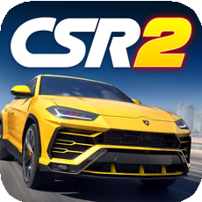  CSR Racing 2  Race real, custom street cars! Developer: NaturalMotion  ★★★★☆ 126.1K reviews
Relevance | Excellent
Fits into the broad category specified by the query. Any racing-themed game would be an
Excellent result here.
clicker heroes |   Idle Heroes - Idle Games Ultimate Hero Battles Developer: droidhang  ★★★★☆ 9.2K reviews
Relevance | Excellent
Both games are idle role-playing games with a fantasy theme, so this is an ideal result.
pubg |   Rules of Survival  Favored by 230 Million Players Developer: NetEase Games  ★★★★☆ 143.5K reviews
Relevance | Excellent
The query is for a realistic Battle Royale-style shooting game, and the ad is a very similar game that competes for the same players.

Good Game Examples
Downgrade to Good for games that are close enough to the intent or play style and presentation suggested by the query to be logical and potentially of interest to the user,
but that seem less strongly linked to the query.
The weakness might be in the game’s play style, themes, and/or perceived target audience.
Query | Ad
strategy game |   Idle Heroes - Idle Games Ultimate Hero Battles Developer: droidhang  ★★★★☆ 9.2K reviews
Relevance | Good

Query | Ad
This idle RPG provides an experience with only some elements of strategy, focusing more on character customization, so it isn't an ideal result, but is still reasonably likely to be of interest
to the user.
spiral roll | 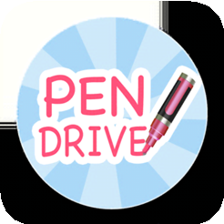  Pencil Marking  Measure your alignment. Developer: Zulyeha Candan
Relevance | Good
Although these games may appear different from each other in theme and presentation, a closer look shows that both are games of skill that require excellent hand-eye coordination.

Ads for accessory apps, which provide some kind of add-on or extra functionality to the game the user was searching for, should also be rated Good:

Query | Ad
minecraft |   Addons for Minecraft  Add-ons, Maps, and Minigames Developer: Kayen Works  ★★★★★17K reviews
Relevance | Good
This Minecraft add-on app will enhance the game experience and would be appealing to a
user with an interest in this game.

Acceptable Game Examples
Rate Acceptable for games that have a slight relation to the user query or named game, and that users would not be surprised or offended to see as ads, but that they aren’t that likely to be interested in.

Query | Ad
fun run | 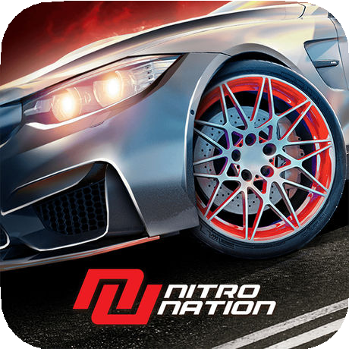  Nitro Nation Online  Real Drag Racing! Developer: Creative Mobile  ★★★★☆ 1.4K reviews
Relevance | Acceptable

Query | Ad
User Query is for games in the Fun Run series, an online 2D running game involving furry cartoon animals, while the advertised app is a realistic car racing game. While both could be considered a form of racing game, their play style and themes are quite different. A user would
probably understand why they were seeing this ad, but wouldn’t be particularly likely to click.
science games |   Elevate - Brain Training  Award-winning brain games Developer: Elevate, Inc.  ★★★★☆ 42.6K reviews
Relevance | Acceptable
These brain-training games are not themed around science. As they are at least games designed to help your mental acuity, it doesn’t seem jarringly different enough from the query to catch a user’s attention, but it’s not likely to be of interest.
call of duty |   Drogon War Ultimate  Developer: Cliff David
Relevance | Acceptable
Both Call of Duty and Drogon War are action/shooting games, but have different presentations and themes. One has a realistic war theme and the other is a fantasy dragon-riding adventure.

If the query specifies that the app should be “new” or “popular”, those that are older or less popular will not be as relevant to the user. Web research, along with the app's Version
History link, can provide more information about an app’s age.

Query | Ad
new dr who games |   Dr Who: Legacy  Role Playing  Developer: Tiny Rebel Games  ★★★★☆ 252 reviews
Relevance | Acceptable
Query is not just for Dr Who games, but for new Dr Who games. The app’s Version History shows that Dr Who: Legacy was first released in 2014 and has not been updated since 2017. Research reveals that newer Dr Who games exist, including this one, released in 2018.

Bad Game Examples

Rate Bad for any cases where the game returned is for something that doesn’t match the query in any way, or the presentation of or audience for of the intent and ad seem so mismatched as to be potentially embarrassing.

Query | Ad
puppydog clicker |   Idle Heroes - Idle Games Ultimate Hero Battles Developer: droidhang  ★★★★☆ 9.2K reviews
Relevance | Bad
The query and the game in the ad are in the same category, as both are idle games, but the user is interested in a game themed around cute dogs and cats, and the advertised game is set in a fantasy universe with wizards, swords and monsters, so the two seem to serve very
different markets.
dunknation 3x3 |   Gymnastics Superstar  Get a perfect 10! Developer: Coco Play  ★★★★☆ 56.8K reviews
Relevance | Bad
The query is for a street basketball game. While the result is also a kind of sports game, their themes are jarringly different and are directed at different audiences.
zombie highway | 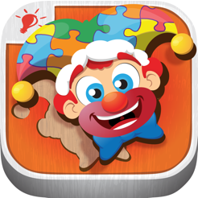  Kids Puzzles Games Puzzingo Toddler Puzzle, Learning Game Developer: 77 Sparx Studio, Inc  ★★★★☆ 1.1K reviews
Relevance | Bad
This horror-theme racing game and children’s puzzle game have nothing in common, and neither would appeal to a user of the other.

